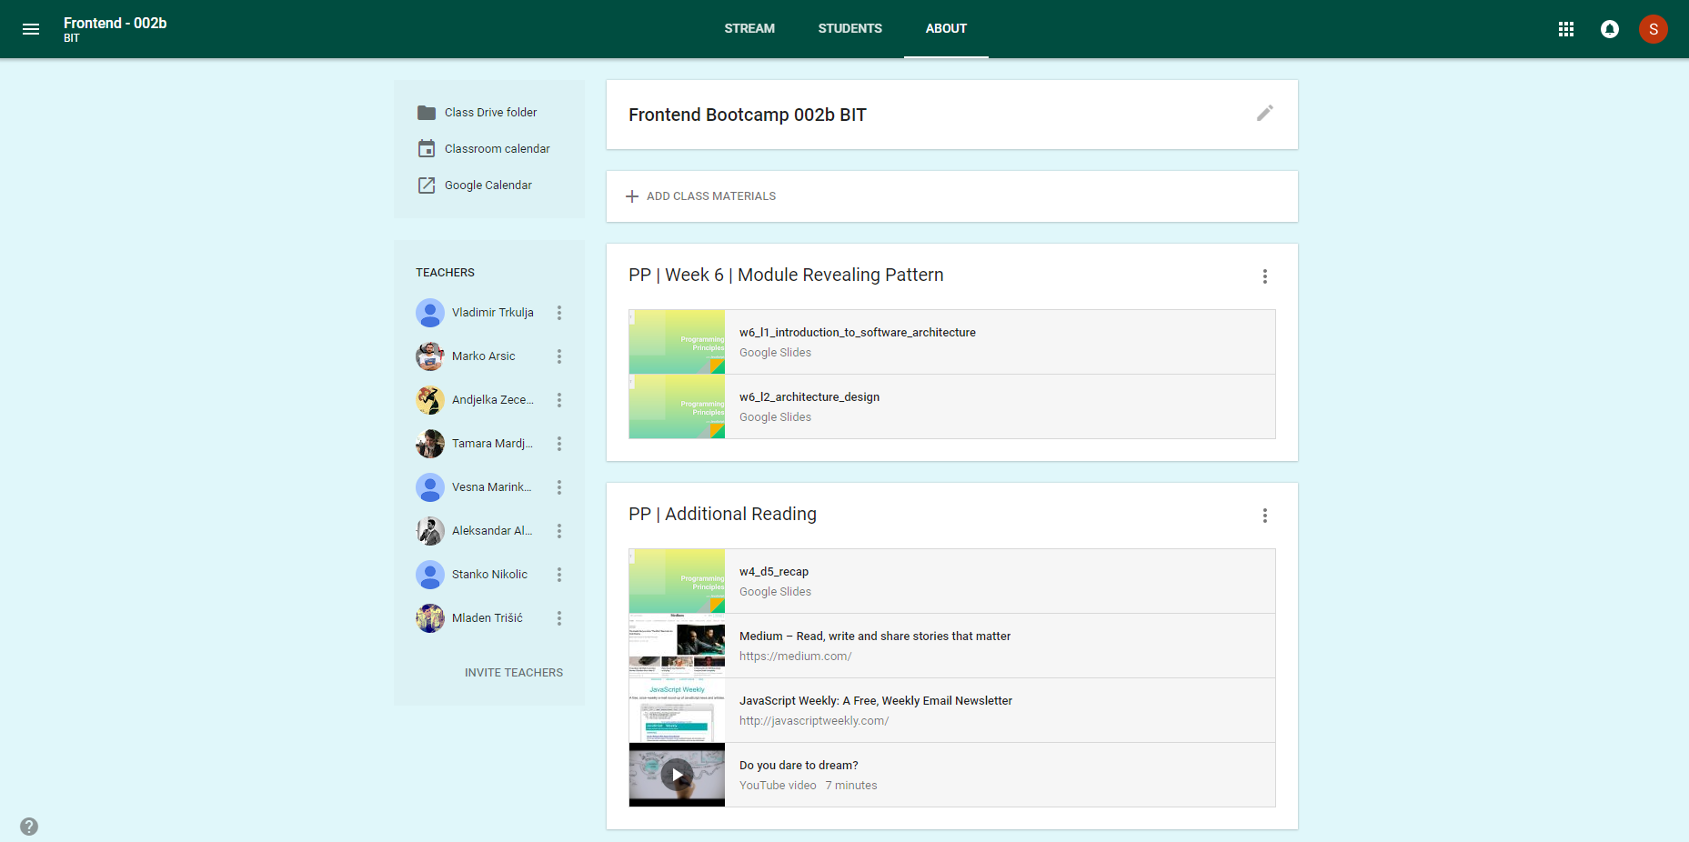

<App>

<Header>

<Navigation>

<MenuList>

<li>About</li>

</MenuList>

</Navigation>

</Header>

<Main>

<Sidebar>

<SidebarActions>

<Link>

</SidebarActions>

<SidebarMembers>

<MembersList>

<SingleMember>

<img />

<h4>name</h4>

</SingleMember>

</MembersList>

</SidebarMembers>

</Sidebar>

<Feed>

<FeedList>

<FeedBox>

<h1>Title</h1>

<FeedItems>

<SingleItem>

<img />

<h3 />

<p />

</SingleItem>

</FeedItems>

</FeedBox>

</FeedList>

</Feed>

</Main>

</App>